React.js Component Creation

|  |  |
| --- | --- |
| Name | : VUCHA VENKATA SUDHIR |
| Email | : sudhirvucha@gmail.com |
| Roll NO | : 20HU1A0454 |

College Name : Chebrolu engineering college

Phone number: 8374914819

Source Code:

CARD COMPONENT:

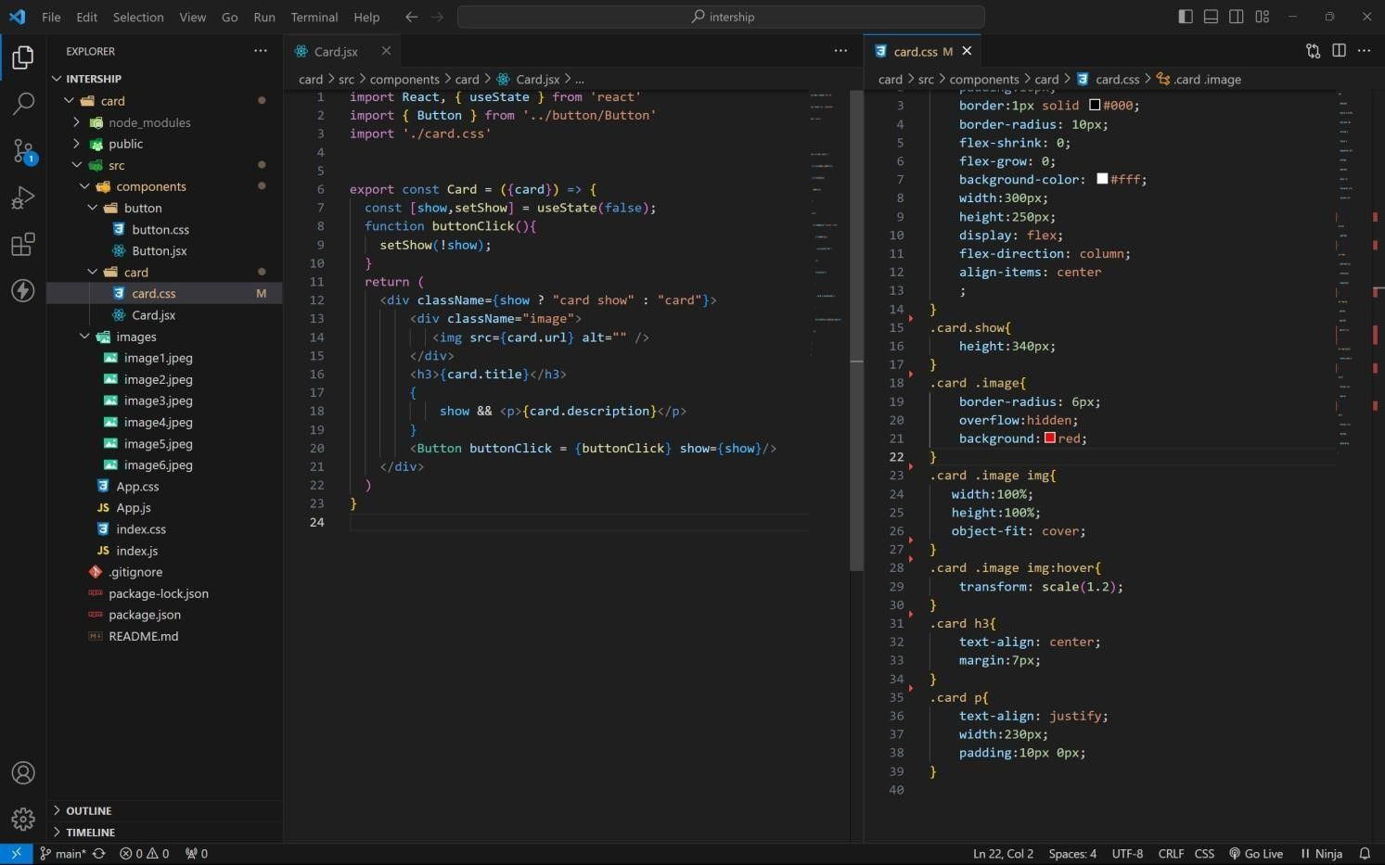

BUTTON COMPONENT:

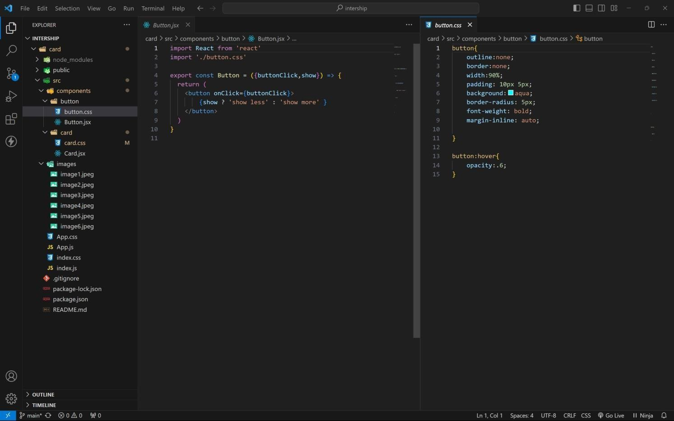

APP COMPONENT:

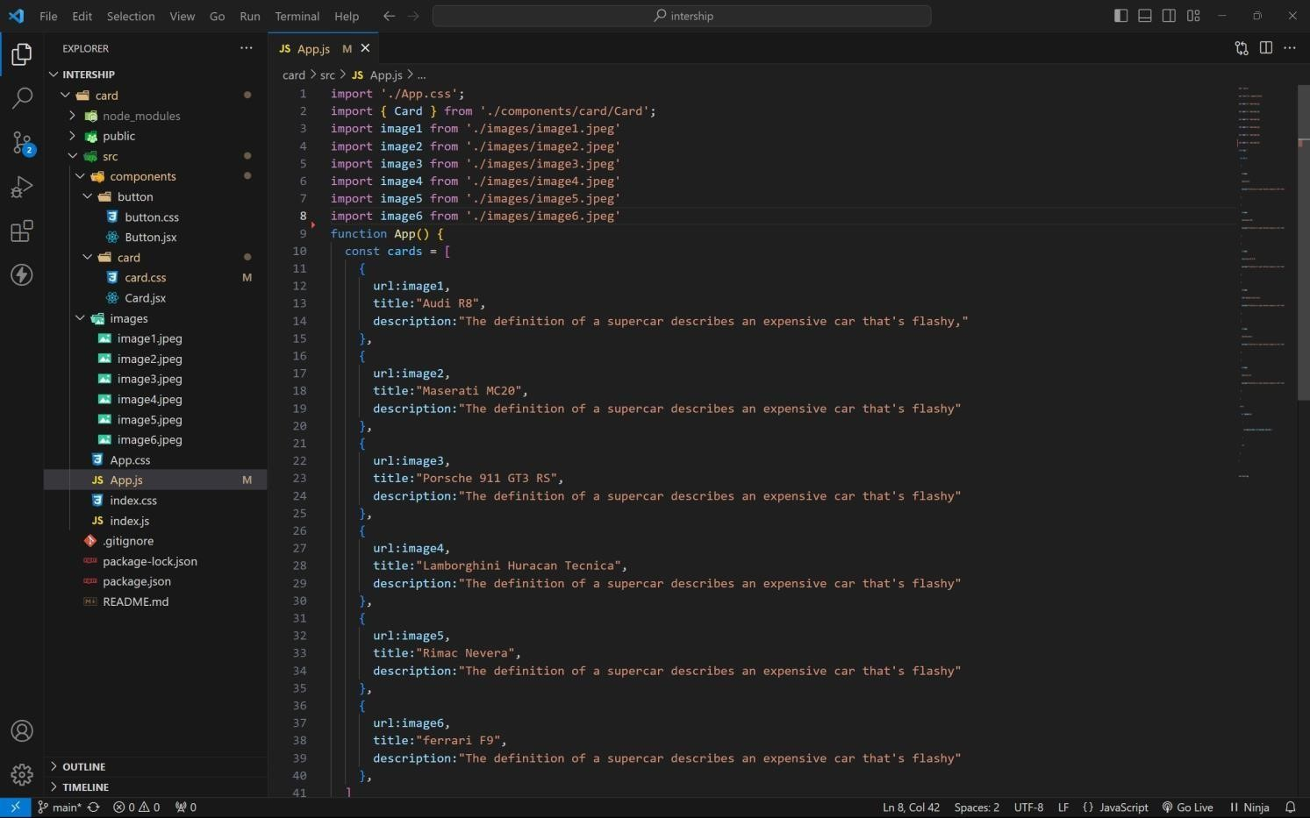

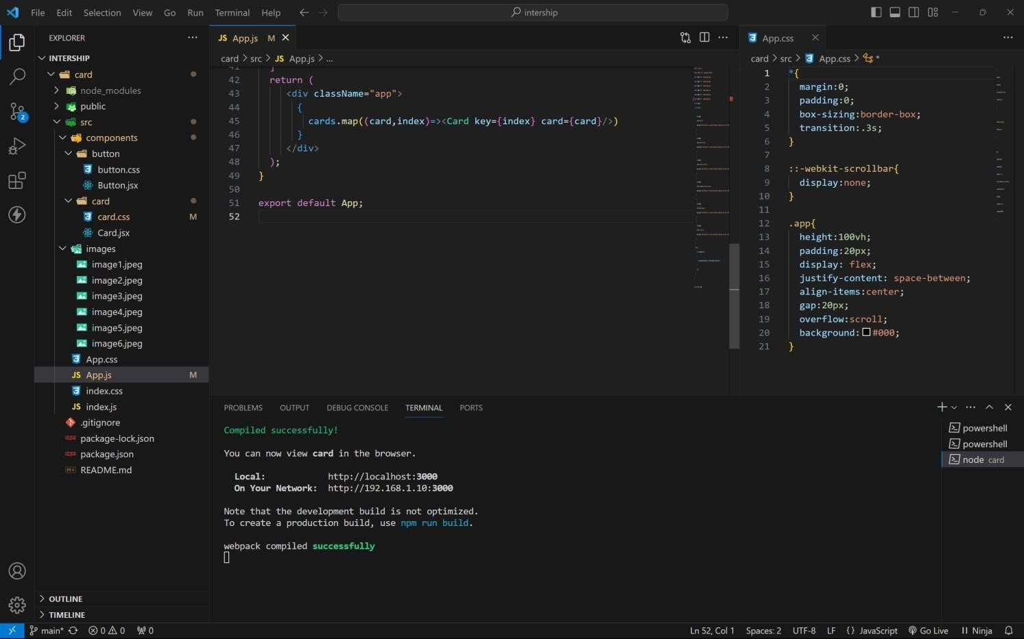

Approach:

1. . initially taking an array of objects like below

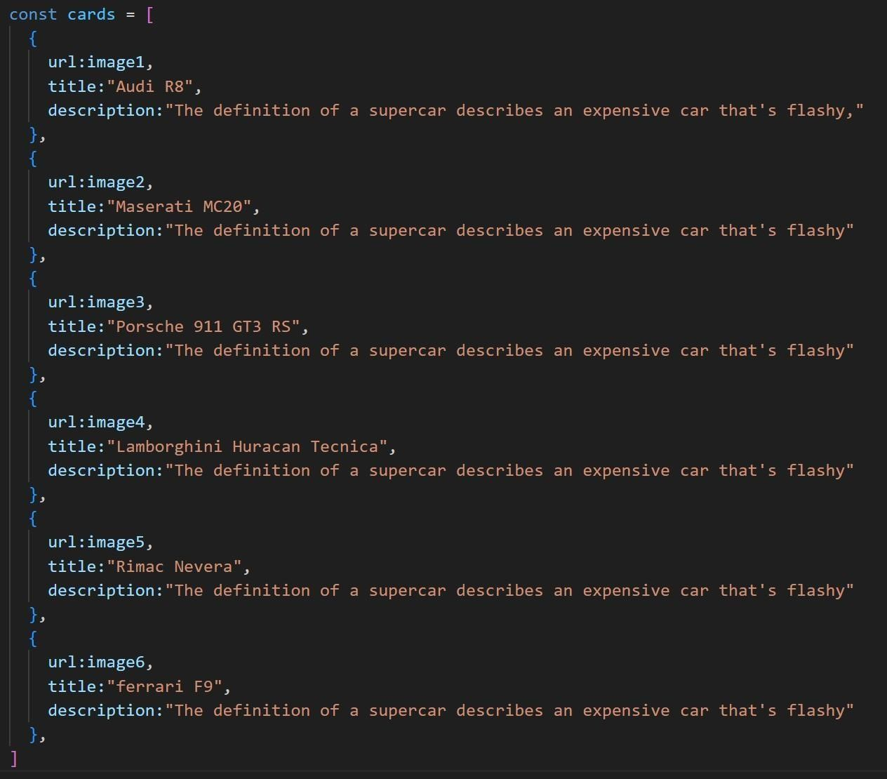

1. . Passing this card array to child (card component) of App component by using props;
2. . getting data as argument like {card} in card component.
3. . in card component i use one state [show, set Show] to get extra info as description.
4. . When we click the button then show becomes true by assigning set Show (! show).

OUTPUT:

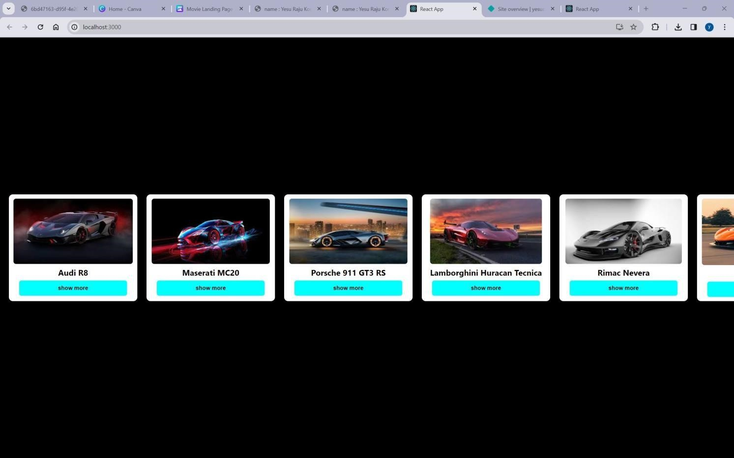

AFTER BUTTON CLICKS:

